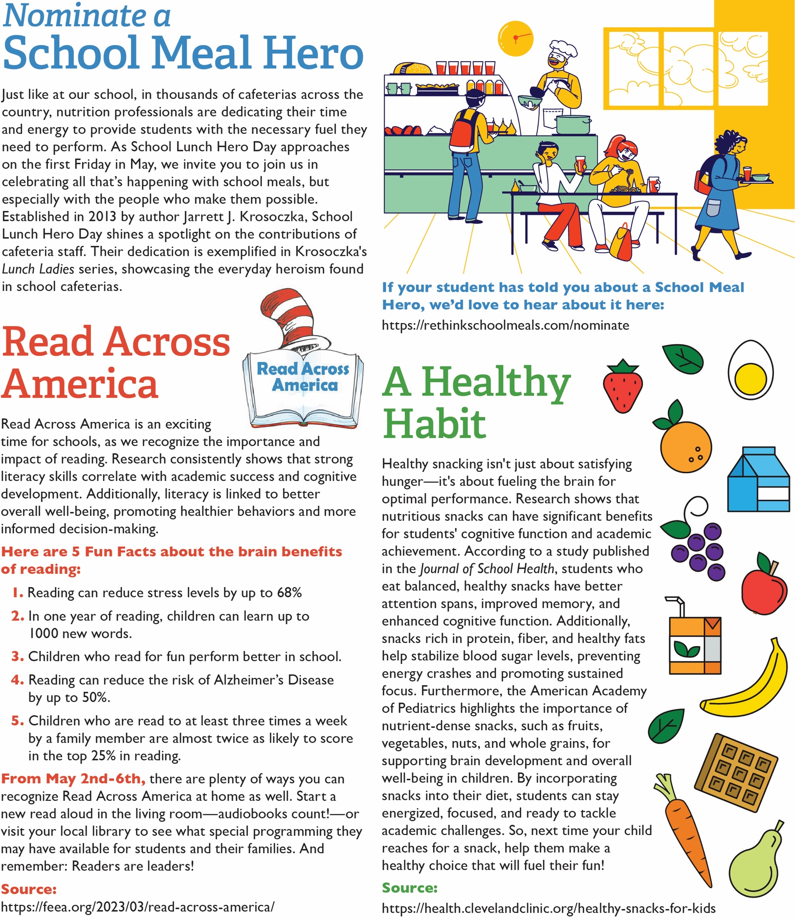

<https://www.conagrafoodservice.com/>

<https://rethinkschoolmeals.com/>

<https://health.clevelandclinic.org/healthy-snacks-for-kids>

<https://feea.org/2023/03/read-across-america/>

<https://rethinkschoolmeals.com/nominate>